There have been a number of woodland projects taking place near Aldbury in the last couple of years, and each has had a distinct rationale and objective.
What is your vision for the Ashridge woodlands?
The Ashridge woodlands are made up of a patchwork of different character areas. This is a result of the varied history in different parts of the Estate, and the varied management that has taken place over the centuries. The history and wildlife of the woodlands are absolutely intertwined, and the important wildlife features have developed differently in different character areas.
Unfortunately, there is virtually no woodland in England that has not been heavily modified by man. In order to maintain the best possible wildlife habitats in the Ashridge woodlands, some ongoing management is needed.
Our woodland management is intended to provide a biodiverse, species rich and mixed aged woodland environment which maintains the unique character and historic culture of the Estate. Timber income is a by-product of our woodland conservation work, not a driver of our woodland management policy.
Why were the conifers in Rail Copse cleared?
Rail Copse is an area designated as an Ancient Woodland site. Ancient Woodlands are defined as having been continuously wooded for over 400 years, although the trees have usually been harvested periodically over the centuries. One of the most important features of an Ancient Woodland is the soil, which contains a multitude of fungi, microbes, invertebrates, and the buried seeds of specialised woodland flowers such as bluebells.
Many Ancient Woodlands were planted with conifers between 1950s – 1980s, and needle drop from these non-native species damages the precious Ancient Woodland soil. This is why we’re removing the conifers from Rail Copse and replacing them with native species. We planted around 1,000 trees in the cleared area last year and will plant another 1,000 in March this year. The area will then be protected by a deer fence to prevent the deer from eating the growing tips of the trees (around 50% of those we planted last year have had their tips nibbled).
The areas of the Estate that are classified as Ancient Woodland are those that were enclosed from the commons in the 1600s or earlier. Most have been felled and replanted within the last 50 years.
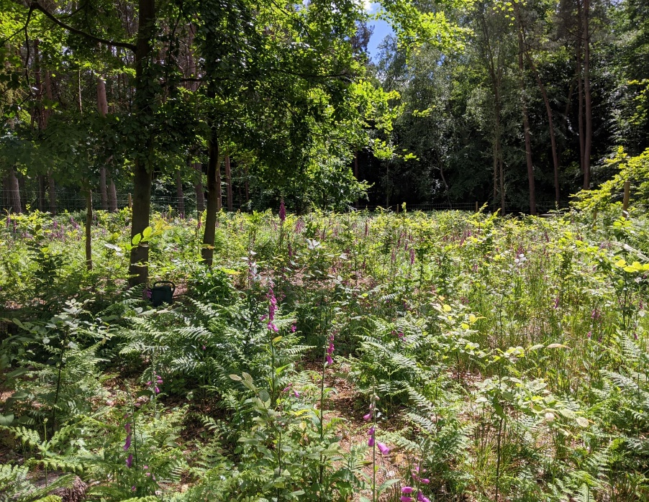

New trees growing in an area of Rail Copse which was replanted as part of a trial in 2019.

The work in Rail Copse has badly cut-up the footpath, and the hard surface is uneven. Is this going to be removed/ repaired to the pre-work condition?
We are working on repairing the footpath in Rail Copse. This has taken much longer than we would have liked, for which we can only apologise.
The muddy clay soils, wet winter weather, large numbers of visitors, and requirement for periodic vehicle access causes real problems at Ashridge due to the lack of surfaced paths. We are aware of this, and it is one of our priorities to improve the infrastructure. However, this is an expensive and complex process due to need to protect the special wildlife and historical features of the site.
We deliberately avoid driving vehicles into the woods when ground conditions are wet and have bought a low ground pressure vehicle for use off road. Unfortunately, once damage has occurred, it takes a long time to recover.

Were all the trees cut down on Tom’s Hill Road this year affected by ash die-back disease?
Yes, with the exception of two sycamores, all the trees that were felled on Tom’s Hill this year were ash trees that were suffering from ash dieback disease.
This year we have felled a lot of ash trees on roadsides and along the edges of footpaths for safety reasons. This is due to ash dieback disease, which is spreading through the country. One of the features of this disease is that it makes the trees incredibly brittle. Trees with advanced disease are dangerous to work on as well as being a danger to the public. We surveyed the Estate in June to determine which ash trees had more than 50% leaf loss, and these were marked for removal.
We are not pre-emptively removing ash trees that are not diseased. We hope that some trees will be resistant to the disease and provide a seed source for the next generation of ash trees. We will also leave trees to decay naturally where it is safe to do so and away from busy footpaths.

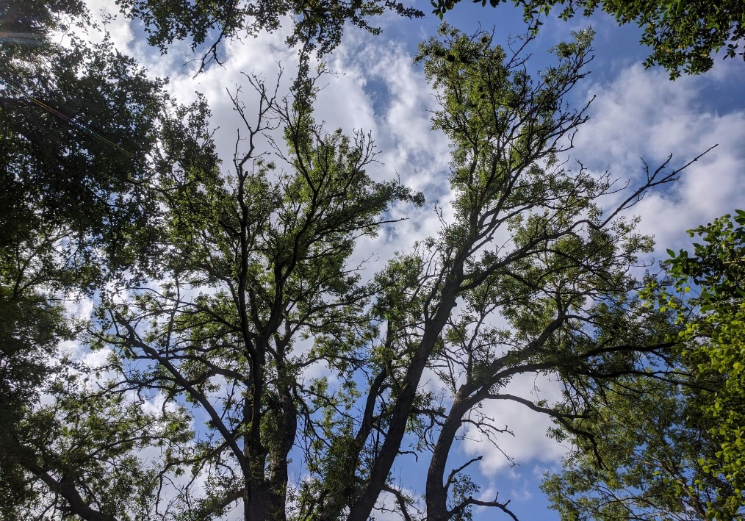

Bare branches on a tree suffering from ash dieback.

Why have tree trunks been left along the roadside on Tom’s Hill Road?
During lockdown we have seen a massive increase in visitors to the Estate and a tendency for cars to park along roadside verges. Parking on verges causes damage to tree roots and wildflowers, and in many cases is dangerous and blocks visibility. The increase in visitors to new areas results in new paths being created and further erosion and degradation of the site. We ask that visitors make use of the existing car parks, and if there is no room, they return later.

